Tutorial of the MultiGS-P (v1.0)
A Genomic Selection Pipeline for Multiple Single Traits Using Diverse Machine Learning and Deep Learning Models and Marker Types

Introduction
MultiGS-P is a Python-based genomic selection pipeline for single-trait genomic prediction using multiple genomic marker representations and predictive models. It provides an end-to-end workflow covering data preprocessing, model training, evaluation, and prediction, with support for both cross-validation (CV) and across-population prediction (APP) scenarios.
This user guide explains how to use the pipeline correctly, how to configure it, and how to interpret outputs.
MultiGS-P enables users to:
- Train genomic prediction models using:
  - SNP markers
  - Haplotype blocks
  - Principal components
- Apply statistical, machine learning, deep learning, and graph-based models
- Evaluate models using:
  - Cross-validation within a population
  - Prediction across genetically distinct populations
- Generate trait-wise predictions, performance summaries, and visual outputs.
- Each trait is modeled independently; the pipeline performs multiple single-trait analyses, not multi-trait modeling.
MultiGS-P is designed for:
- Plant breeding and crop genomics researchers
- Bioinformatics and quantitative genetics practitioners
- Users with working knowledge of genomic data formats and prediction workflows
Supported Workflows
The pipeline supports two mutually exclusive execution modes, selected through configuration:
- Cross-validation (CV):
Used for model benchmarking and evaluation when training and testing samples belong to the same population.
- Across-population prediction (APP):
Used to assess model generalization when predicting phenotypes in a new or independent population.

Data Requirements
Genotype Data
- Input format: VCF (.vcf or .vcf.gz)
- Biallelic SNPs only
- Standard VCF headers required
- Sample IDs must exactly match the phenotype file
Notes:
- No genotype QC is performed internally
- No HWE filtering, LD pruning, or depth-based filtering
- Missing genotypes are handled during preprocessing
Phenotype Data
- CSV or tab-delimited text
- Rows = samples, columns = traits
- First column = sample IDs
- Multiple traits supported
Notes:
- Traits are modeled independently
- Missing values are imputed using trait medians
- Normalization is optional and user-controlled
Feature Views (Marker Representations)
MultiGS-P supports multiple feature views, which define how genotype data are represented for modeling.
- SNP
  - Raw SNP encoding (0/1/2)
  - Highest dimensionality
  - Recommended baseline for most analyses
- HAP
  - SNPs grouped into haplotype blocks
  - Reduced dimensionality
  - Captures local linkage disequilibrium
  - Requires external SNPLDB tool
- PC
  - Principal components derived from SNPs
  - Strong dimensionality reduction
  - Captures population structure rather than individual marker effects
Feature views can be used individually or in combination. Using multiple views increases computational cost and model complexity.
Sample Alignment
- Only samples present in both genotype and phenotype files are used
- Sample order is synchronized internally
- In APP mode, only SNPs common to training and test sets are retained

Installation and Environment Setup
MultiGS-P is executed within a Conda environment that contains all required dependencies.
Requirements
- Linux system recommended
- Python ≥ 3.9
- CPU supported; GPU recommended for DL and GNN models

1. Clone the Repository
git clone https://github.com/AAFC-ORDC-Crop-Bioinfomatics/MultiGS-P.git
cd MultiGS-P

2. Create the Conda Environment
conda env create -f environment.yml
conda activate multigs_p

3. Installing rtm-gwas-snpldb tool
The rtm-gwas-snpldb tool for haplotype block identification is included in the utilities folder in this repository. The latest executable can also be downloaded separately from: https://github.com/njau-sri/rtm-gwas

Configuration File Overview
All pipeline behavior is controlled through a single INI configuration file. No code changes are required.
```
[General]
seed = 42
threads = 10
n_replicates = 1
n_folds = 5
R_path = /path_to_R
results_dir = results

[Data]
vcf_path = ../../inputFile/train_genotype.vcf
phenotype_path = ../../inputFile/train_phenotype.txt

pca_variance_explained = 0.95 # Use enough components to explain 95 percent variance
pheno_normalization = standard
genotype_normalization = standard

# For prediction mode, this section should be commented
# test_vcf_path =
# test_phenotype_path =

[Tool]
rtm-gwas-snpldb_path = ../../../Pipelines/Utilities/rtm-gwas/rtm-gwas-snpldb

[FeatureView]
feature_view = HAP # SNP,HAP,PC: one, any two, or all three separated by ','

[Models]
R_RRBLUP = true
R_GBLUP = true
RRBLUP = true
DeepResBLUP = true
DeepBLUP = true
ElasticNet = true
RFR = true
BRR = true
XGBoost = true
LightGBM = true
MLPGS = true
DNNGS = true
GraphConvGS = true
GraphAttnGS = true
GraphSAGEGS = true
GraphFormer = true
EnsembleGS = true

[Hyperparameters_R_RRBLUP]
method = REML #REML|ML

[Hyperparameters_R_GBLUP]
method = REML #REML|ML

[Hyperparameters_RRBLUP]
lambda_value = None
method = mixed_model
lambda_method = auto # Options: auto|reml|heritability|fixed
tol = 1e-8

[Hyperparameters_ElasticNet]
# Reduce regularization for ElasticNet: fro, 1 to 0.1->0.01->0.001
alpha = 1.0
l1_ratio = 0.1 # toward ridge: from 0.5 to 0.1-0.3

[Hyperparameters_LASSO]
alpha = 1.0

[Hyperparameters_XGBoost]
n_estimators = 100
max_depth = 6
learning_rate = 0.1
subsample = 0.8
colsample_bytree = 0.8
random_state = 42

[Hyperparameters_LightGBM]
n_estimators = 100
max_depth = -1
learning_rate = 0.1
num_leaves = 31
subsample = 0.8
colsample_bytree = 0.8
random_state = 42

[Hyperparameters_MLPGS]
hidden_layers = 1024,512,256
activation = gelu
norm = layer
residual = true
input_dropout = 0.05
dropout = 0.5

learning_rate = 0.0005
weight_decay = 0.0015
batch_size = 16
epochs = 300
early_stopping_patience = 20
warmup_ratio = 0.1
grad_clip = 1.0
seeds = 3

use_huber = true
huber_delta = 1.0

swa = true
swa_start = 0.7
swa_freq = 1

[Hyperparameters_DNNGS]
hidden_layers = 512,256,128,64
learning_rate = 0.001
batch_size = 32
epochs = 300
dropout = 0.3
activation = gelu
batch_norm = true
weight_decay = 0.0001
input_dropout = 0.1

[Hyperparameters_GraphConvGS]
hidden_channels = 128
num_layers = 2
hidden_mlp = 128
dropout = 0.2
learning_rate = 0.0005
epochs = 500
top_k = 20
graph_method = knn
knn_metric = euclidean
patience = 20

[Hyperparameters_GraphAttnGS]
hidden_channels = 128
num_layers = 2
heads = 4
hidden_mlp = 128
dropout = 0.2
learning_rate = 0.0005
epochs = 500
top_k = 20
graph_method = knn
knn_metric = euclidean
patience = 20

[Hyperparameters_GraphSAGEGS]
hidden_channels = 128
num_layers = 2
hidden_mlp = 128
dropout = 0.2
learning_rate = 0.0005
epochs = 500
top_k = 20
graph_method = knn
knn_metric = euclidean
aggr = mean
patience = 20

[Hyperparameters_GraphFormer]
gnn_type = SAGE # Choose: SAGE|GraphConvGS|GraphAttnGS
gnn_hidden = 128 # Output size of GNN layer
transformer_layers = 2 # Number of transformer layers
d_model = 128 # Transformer dimension
nhead = 4 # Number of attention heads
mlp_hidden = 128 # MLPGS hidden size
learning_rate = 0.001
epochs = 500
patience = 30
dropout = 0.1
weight_decay = 0.001
graph_method = knn
knn_metric = euclidean
top_k = 30

[Hyperparameters_DeepResBLUP]
base_model = R_RRBLUP
dl_model = MLPGS # MLPGS|DNNGS|hybrid (hybrid: marker-transformer + optional sample GNN, very slow)
dl_hidden_layers = 128,64
dl_dropout = 0.2
dl_learning_rate = 0.001
dl_batch_size = 32
dl_epochs = 100

[Hyperparameters_DeepBLUP]
rrblup_lambda = 0.001
dl_hidden_layers = 128,64,32
dropout = 0.3
activation = gelu
use_precomputed_rrblup = true
train_rrblup_layer = true
learning_rate = 0.0001
batch_size = 16
epochs = 200
weight_decay = 0.0001
use_batch_norm: true
use_residual_connections: true

[Hyperparameters_EnsembleGS]
# models available for stacking
# 'R_RRBLUP', 'R_GBLUP', 'RRBLUP',
# 'ElasticNet', 'RFR', 'BRR',
# 'XGBoost', 'LightGBM',
# 'DNNGS', 'MLPGS',
# 'GraphConvGS','GraphAttnGS', 'GraphSAGEGS', 'GraphFormer',
# 'DeepResBLUP', 'DeepBLUP',
base_models = R_RRBLUP,ElasticNet,BRR, LightGBM, MLPGS
meta_model = linear # linear|ridge
meta_alpha = 1.0
```

[General] — Execution and Reproducibility
Controls experiment structure and system resources.
- seed
Sets global randomness. Ensures statistical reproducibility, not exact determinism.
- threads
Number of CPU threads used by models that support parallelism.
- n_replicates
Number of repeated CV runs. Increase for more stable estimates at higher cost.
- n_folds
Number of CV folds (used only in CV mode).
- R_path
Path to R executable. Required for R-based models only.
- results_dir
Output directory. Created automatically if it does not exist.
[Data] — Input Files and Preprocessing
Defines genotype, phenotype, and normalization behavior.
- vcf_path, phenotype_path
Training genotype and phenotype files (required).
- test_vcf_path, test_phenotype_path
Enable across-population prediction (APP) when provided.
- pca_variance_explained
Used only when PC feature view is enabled.
- pheno_normalization, genotype_normalization
Scaling applied before modeling. No normalization is applied unless specified.

[Tool] — External Dependencies
- rtm-gwas-snpldb_path
[FeatureView] — Marker Representation
Controls how genotype data are represented.
- feature_view
Options: SNP, HAP, PC, or combinations separated by commas.
Guidance:
- Start with SNP
- Use HAP or PC only when SNP dimensionality is high
- Multiple views increase runtime and complexity

[Models] — Model Selection
Each model is enabled or disabled explicitly.
Rules:
- At least one model must be enabled
- Linear models should always be included as baselines
- Deep learning and graph models are computationally expensive

[Hyperparameters_*] — Model-Specific Settings
Each enabled model reads parameters from its corresponding section.
- Defaults are conservative and stable
- Aggressive tuning increases overfitting risk
- Graph and deep learning models have the highest sensitivity to hyperparameters
- Ensemble models only use predictions from listed base models

Running the Pipeline
Once the configuration file is prepared, the pipeline can be executed directly. No code modification is required.

Activate Environment
- conda activate multigs_p
Run the Pipeline
- python MultiGS-P_1.0.pyc --config config.ini
Execution Behavior
- Each trait is processed independently
- Enabled feature views and models are executed sequentially
- Progress and errors are written to log files
- Runtime depends on:
  - Number of samples and markers
  - Enabled models
  - Feature views used
  - Available CPU/GPU resources

Output Location
All results are written under the directory specified by results_dir.

Understanding the Output
MultiGS-P organizes results by execution mode and analysis type. Outputs are deterministic in structure and written under the directory specified by results_dir
phenotype_analysis/
Basic descriptive analysis of training phenotypes:
- Summary statistics
- Histograms
- Correlation matrices and heatmaps
Used for data inspection only; not model-dependent.
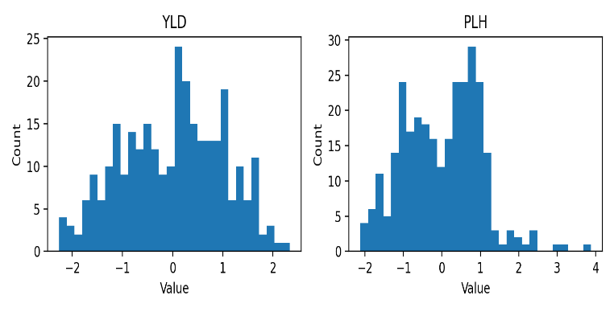
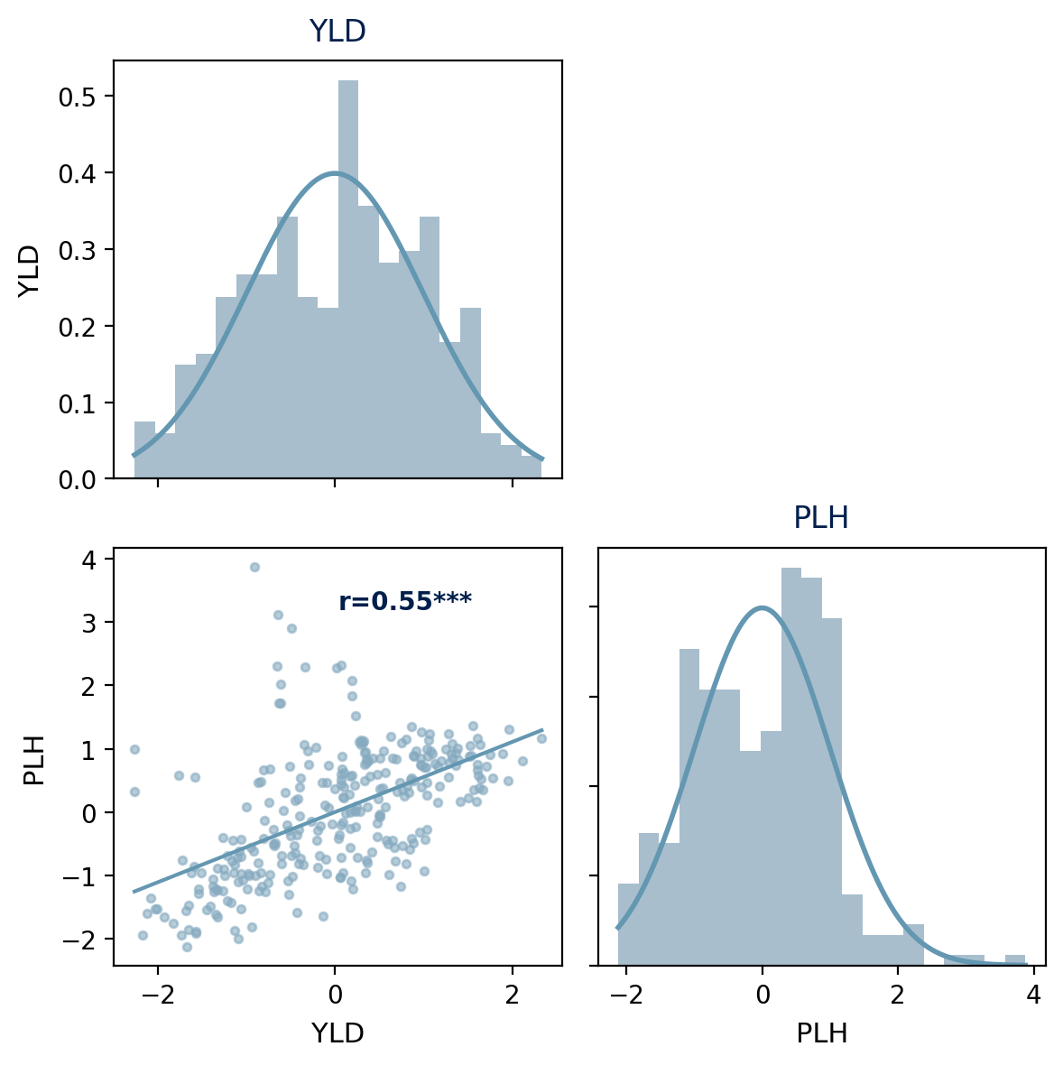

ckpts/
Saved model checkpoints:
- Best-performing models per feature view
- Used for prediction and reproducibility
- Mainly relevant for deep learning and graph models
intermediate_data/
Temporary and derived files:
- Converted or harmonized VCFs
- Haplotype block files (HAP view)
- Train–test merged genotype files (APP)
These files support reproducibility and debugging.
Runtime and Resource Summaries
- training_times_summary.csv
- training_times_comparison.png
- training_memory_usage_summary.csv
- training_memory_usage_comparison.png
Used to compare computational cost across models.
Cross-Validation–Specific Outputs
Located under crossvalidation/results/.
- cv_gs_results.json
Raw CV results per model, trait, and fold.
- cv_gs_detailed_results.csv
Fold-level performance metrics.
- cv_gs_summary_stats_*.csv
Aggregated statistics across folds and replicates.
- Boxplots:
  - Performance by trait
  - Performance by model
  - Grouped comparisons across feature views

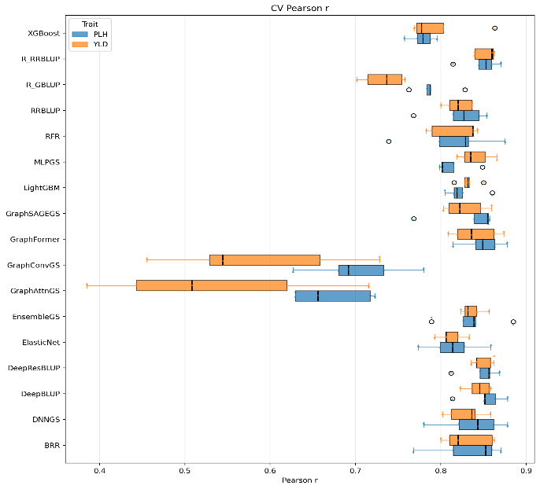
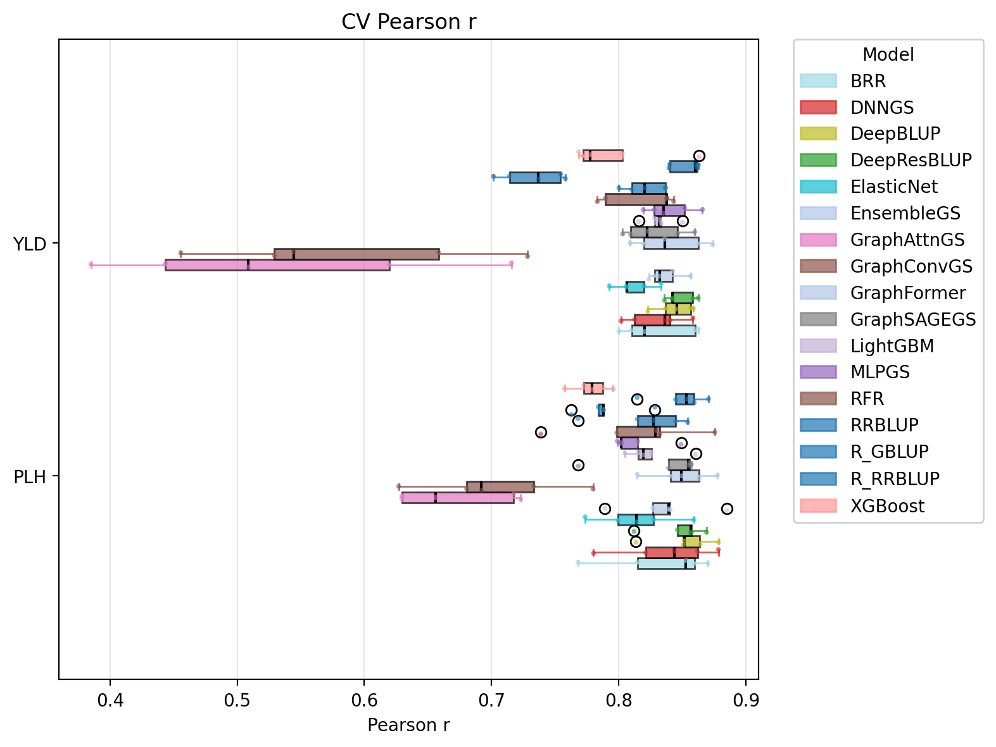

anova/
Statistical comparison of models:
- ANOVA tables
- Tukey HSD results
- Group mean summaries
Used for formal model comparison across traits.
Prediction–Specific Outputs
Located under prediction/results/.
scatter_plots/
Observed vs predicted plots:
- Per model and per trait
- Combined plots across models
Used for visual assessment of prediction quality.
trait_predictions/
Final prediction outputs:
- Model-specific prediction files
- Trait-wise combined prediction tables
- Correlation matrices across models and feature views
- Summary statistics per trait
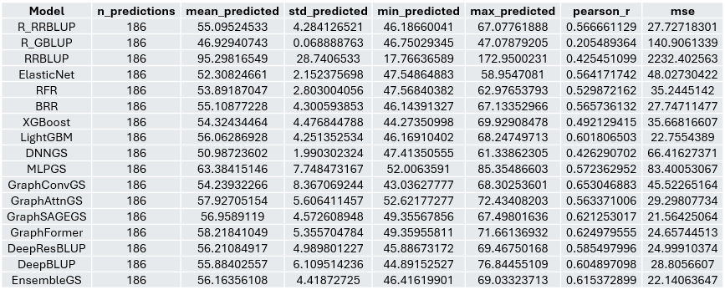

These files are the primary outputs for downstream analysis and reporting.
Population Structure Visualization
- mds_grm_scatter_plot.png
- mds_grm_scatter_plot_values.csv
Shows genetic relationships between training and prediction samples.
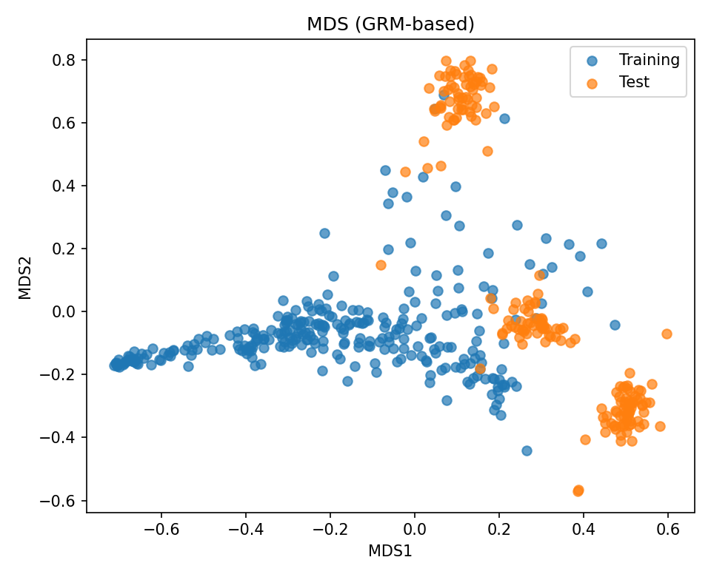

Log Files
Each run produces a timestamped log file:
- CV: gs_cross_validation_*.log
- Prediction: gs_prediction_*.log
Logs include:
- Execution steps
- Model progress
- Errors and warnings
Always check logs if results are missing or incomplete.

